Charles Henderson

Reuel Maddela

Harpreet Sidhu

Activity 8

AJAX partial view of the Customer page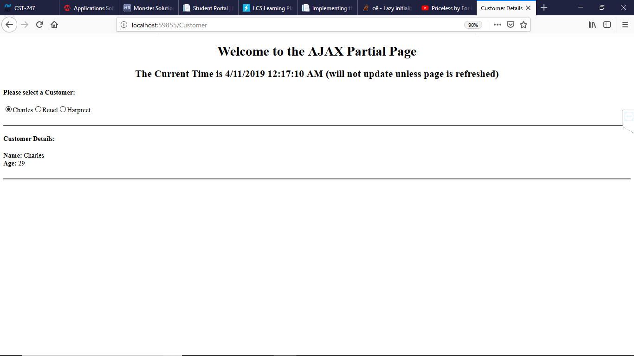

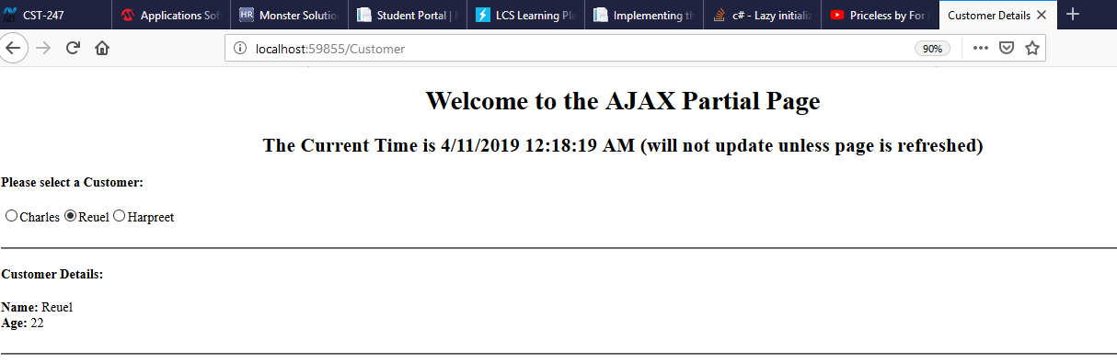

The partial page update then changes the names, but then not the current time: 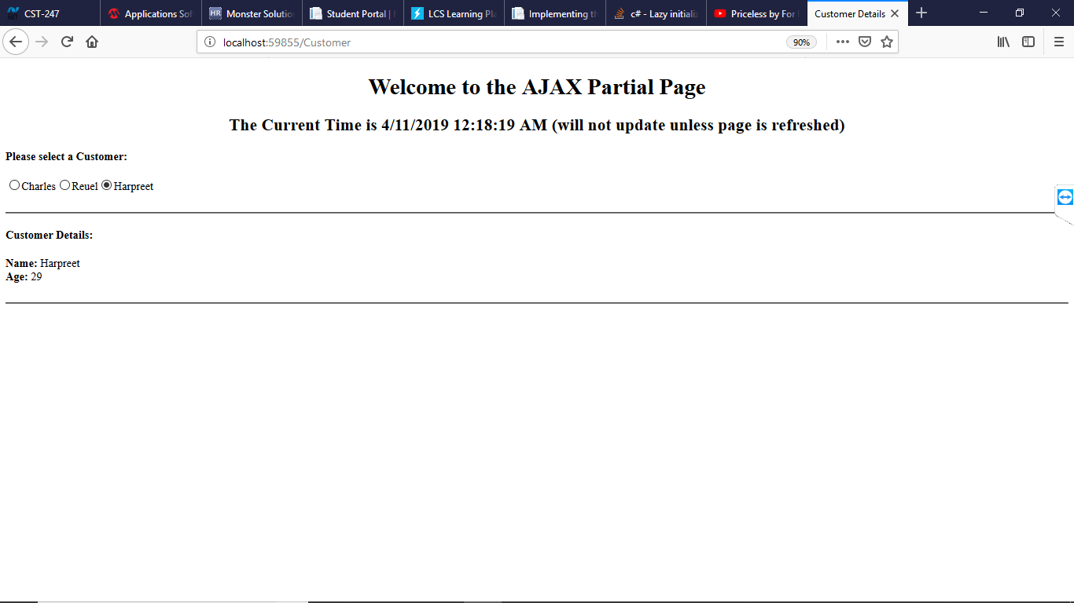

AJAX Callback alert when click action is performed: 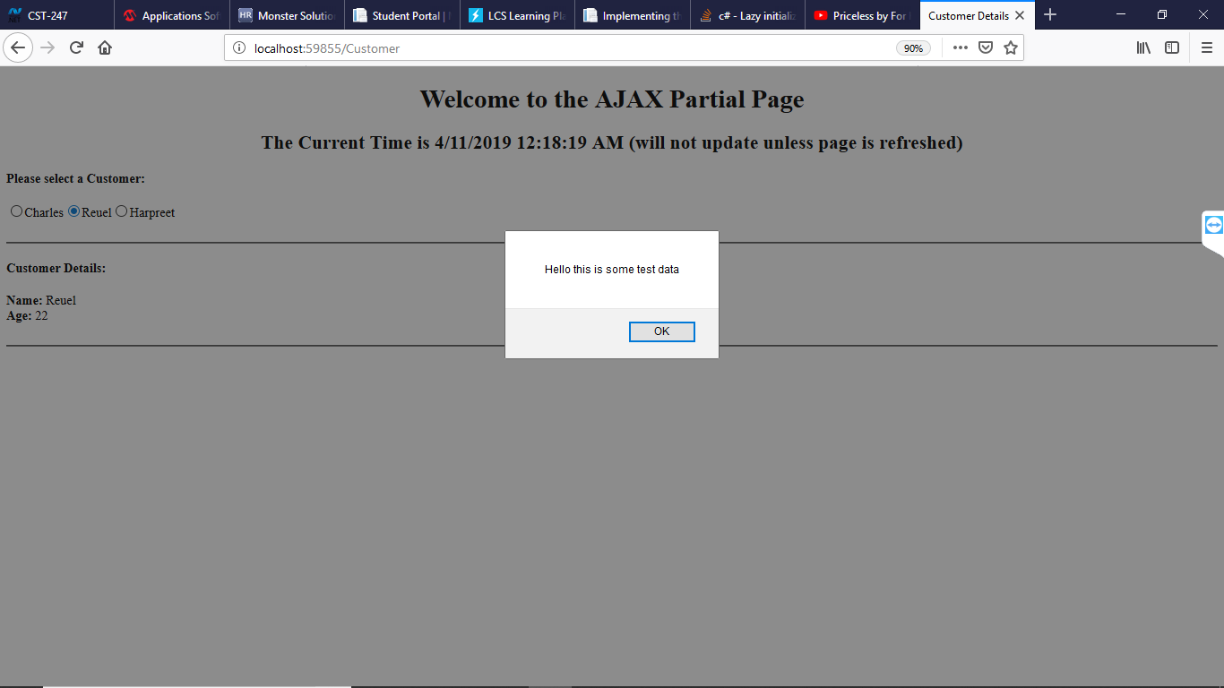

These projects are too large and can’t be uploaded to loudcloud, so the code can be accessed from:

https://github.com/agingdanger/CST-247